SOFTWARE REQUIREMENTS SPECIFICATION
(SRS)

for the

NATIONAL INNOVATION REPOSITORY (NIR) PLATFORM

Prepared in conformance with ISO/IEC/IEEE 29148:2018
"Systems and software engineering — Life cycle processes — Requirements engineering"

Prepared for
Aspire to Innovate (a2i)
Information & Communication Technology Division, Government of Bangladesh

Document Version: 1.0 | Status: Draft for Review
Source Reference: Terms of Reference (TOR) — National Innovation Repository (NIR) Platform, a2i, ICT Division

Table of Contents
1. Introduction
2. Overall Description
3. System Features (Functional Requirements)
3.1–3.8 Component 1 – 8 (see Section 5 of the source TOR)
3.9 UML Diagrams: User Categories and Their Flows
4. External Interface Requirements
5. Non-Functional Requirements
6. Data Requirements & Legacy Data Migration
7. Requirements Traceability Matrix
8. Appendices

1. Introduction

1.1 Purpose
This Software Requirements Specification (SRS) defines the functional and non-functional requirements for the National Innovation Repository (NIR) Platform, commissioned by Aspire to Innovate (a2i), ICT Division, Government of Bangladesh. This document translates the approved Terms of Reference (TOR) into a structured requirements baseline, prepared in conformance with ISO/IEC/IEEE 29148:2018, to guide system design, development, testing, and acceptance.
This SRS is intended to serve as the contractual and technical reference against which the selected vendor's system design, development, and User Acceptance Testing (UAT) will be measured.

1.2 Document Conventions
This document uses the following conventions:
- Each functional requirement is assigned a unique identifier in the form FR-C<component>.M<module>.<sequence> (e.g., FR-C1.M1.01).
- Each requirement is assigned a priority of High, Medium, or Low, reflecting relative implementation priority, not contractual obligation — all stated requirements are mandatory deliverables under the TOR unless the vendor and a2i jointly agree otherwise in writing.
- The keywords "shall" indicates a mandatory requirement; "should" indicates a recommended requirement; "may" indicates an optional or future-phase capability.
- Use case identifiers follow the form UC-<component>.<sequence>.

1.3 Intended Audience and Reading Suggestions
This document is intended for:
- a2i project authority and the ICT Division, for review and approval of scope.
- The selected vendor's business analysts, architects, and developers, as the primary basis for system design and development.
- QA/testing teams, to derive test cases and the traceability matrix.
- Procurement, legal, and audit stakeholders, for compliance verification.

1.4 Project Scope
The NIR Platform is a centralized, web-based (and optionally mobile-accessible) digital ecosystem that documents, evaluates, recognizes, and promotes innovations originating from individuals, academia, government agencies, startups, and civil society across Bangladesh. The platform comprises eight core components: (1) Innovation Submission & Evaluation, (2) Innovation Funding Matchmaking, (3) Repository & Knowledge Management, (4) Communication & Stakeholder Engagement, (5) Performance Monitoring & Reporting, (6) Mentorship & Expert Guidance, (7) Innovation Management, and (8) Ministry Innovation Submission & Annual Reporting.
The system will be hosted at the National Data Center (NDC) under the Bangladesh Computer Council (BCC), will integrate with national identity, messaging, and administrative systems (NID/Birth Registration, SMS gateway, BIN, e-Nothi), and will support Single Sign-On (SSO) authentication.

1.5 Definitions, Acronyms, and Abbreviations
Acronym | Full Form
NIR | National Innovation Repository
a2i | Aspire to Innovate
SRS | Software Requirements Specification
SDD | System Design Document
API | Application Programming Interface
UI/UX | User Interface / User Experience
CI/CD | Continuous Integration / Continuous Deployment
QA | Quality Assurance
UAT | User Acceptance Testing
SLA | Service Level Agreement
BRC | Birth Registration Certificate
NID | National Identity Database
e-Nothi | Government Electronic Filing System
SSO | Single Sign-On
ICT | Information and Communication Technology
DR | Disaster Recovery
CMS | Content Management System
OTP | One-Time Password
BCC | Bangladesh Computer Council
NDC | National Data Center
LGD | Local Government Division
OWASP | Open Worldwide Application Security Project
DPDT | Department of Patents, Designs and Trademarks
IPR | Intellectual Property Rights
IRN | Innovator Recognition Number (system-generated unique innovator ID)
FR | Functional Requirement
NFR | Non-Functional Requirement
UC | Use Case
RBAC | Role-Based Access Control
WCAG | Web Content Accessibility Guidelines

1.6 References
- ISO/IEC/IEEE 29148:2018 — Systems and software engineering — Life cycle processes — Requirements engineering.
- Terms of Reference (TOR) for the National Innovation Repository (NIR) Platform, a2i, ICT Division (source document for this SRS).
- OWASP Top 10 Web Application Security Risks.
- Web Content Accessibility Guidelines (WCAG) 2.2, Level AA.
- Digital Service and Web Designing Guideline for Inclusive Accessibility, 2022 (Government of Bangladesh).

2. Overall Description

2.1 Product Perspective
The NIR Platform is a new, standalone national digital system, hosted at the National Data Center (NDC) and operated by a2i. It is not a replacement for any existing system but is designed to interoperate with several external systems, namely: NID/Birth Registration (identity verification), SMS Gateway (alerts/OTP), BIN verification API (investor onboarding), e-Nothi (administrative approvals and logging), Google Maps (location tagging), and third-party SSO providers (Google, Apple). The platform is architected as a modular, service-oriented system to allow incremental delivery and future integration with additional government and private-sector systems.
Governing all of the above: the entire platform's content layer — public portal pages, blogs, FAQs, success stories, notification templates, and multilingual copy — shall be managed through a single, centralized Content Management System (CMS), specified as Component 4, Module 2 (Section 3.4.2). The CMS is the system of record for content; individual functional modules (e.g., Submission, Evaluation, Mentorship) shall consume content and templates from the CMS via internal API rather than maintaining hard-coded or duplicated content. This allows non-technical administrators to update the platform's public-facing content and communication templates without a code deployment.

2.2 Product Functions (Summary)
At a high level, the system shall provide the following functions, detailed fully in Section 3:
- Component 1: Innovation Submission & Evaluation System — This component enables innovators to register, submit, and track innovations, and enables evaluation panels to assess, score, and formally recognize submitted innovations.
- Component 2: Innovation Funding Matchmaking — This component connects evaluated innovations with investors, funders, and development partners, and manages the resulting agreements.
- Component 3: Repository & Knowledge Management — This component provides the searchable public and internal archive of all approved innovations.
- Component 4: Communication & Stakeholder Engagement — This component provides the public-facing portal, administrative dashboard, and multi-channel communication tools that connect all NIR stakeholders.
- Component 5: Performance Monitoring & Reporting — This component tracks platform usage, fund utilization, and key performance indicators for management and donor reporting.
- Component 6: Mentorship & Expert Guidance — This component connects innovators with domain-expert mentors and tracks mentorship engagement.
- Component 7: Innovation Management — This component supports internal, cross-functional tracking of an innovation's lifecycle after submission — including reviewer collaboration and fund-disbursement updates.
- Component 8: Ministry Innovation Submission & Annual Reporting — This component enables government ministries and divisions to submit and track their own innovation contributions on an annual cycle and to generate consolidated ministry-wise reports.

2.3 User Classes and Characteristics
The platform is role-based. The following table summarizes the preliminary user classes carried forward from the TOR; the vendor shall refine RBAC permissions during detailed design.
# | User Class | Est. Users | Primary Roles & Functional Access
1 | Innovation Submitter | 10,000+ | Register and submit innovations; update progress; track review status; receive recognition and feedback.
2 | Institutional Coordinator | 200+ | Review/verify institutional submissions; coordinate internal evaluation; submit institutional reports.
3 | Expert Evaluator / Reviewer | 150+ | Access assigned cases; score and provide feedback; recommend reject/shortlist/fund.
4 | Investor | 100+ | Browse innovation pipeline; express interest; provide financial or technical support.
5 | Stakeholder / Partner | 40+ | Launch events; share data; access repositories; collaborate on innovation activities.
6 | Platform Administrator | 10+ | Full system access; manage users/roles; publish content and notifications; system-wide reporting.
7 | System Administrator | 12+ | Manage hosting, backups, and technical maintenance; enforce security protocols; monitor performance.
8 | Public Viewer / General User | Unlimited | Browse approved innovations; read success stories; search archive; download summaries.
9 | Policy and Strategy Observer | 10–20 | Monitor trends; analyze innovation distribution; contribute to ecosystem strategy.
10 | Innovation Manager | TBD | Track progress; review and comment; upload documents; update fund-disbursement information.
11 | Ministry Innovation Focal Point | 100+ | Coordinate ministry data collection; submit and validate annual innovations; generate ministry reports.
12 | Mentor | TBD | Register as domain expert; conduct mentorship sessions; provide progress feedback.

2.4 Operating Environment
- Server-side: Hosted at the National Data Center (NDC) under BCC, or another a2i-approved environment.
- Client-side: Modern desktop and mobile web browsers (Chrome, Firefox, Safari, Edge), responsive across desktop, tablet, and mobile form factors.
- Network: HTTPS (TLS-encrypted) access over the public internet and government network.
- Integration environment: RESTful APIs over an API Gateway, with JSON/XML payloads.

2.5 Design and Implementation Constraints
- The system must use a modern, scalable technology stack; open-source technologies are preferred, and any proprietary component must be justified.
- Development must follow OWASP secure coding guidelines and Government of Bangladesh digital service/accessibility standards.
- Hosting is constrained to the National Data Center (NDC) / BCC-approved infrastructure.
- All source code and deliverables are the property of the Government of Bangladesh (see Section 5.9, Compliance).
- The platform must support both Bangla and English throughout.
- The CMS shall be deployed in a headless/API-first configuration and integrated with the platform's central RBAC and audit-logging services (Sections 5.2.1 and 5.2.3) rather than operated as an independent, separately-secured system.

2.6 User Documentation
The vendor shall deliver: system architecture documentation, API documentation (Swagger or equivalent), administrator and user manuals, a deployment/troubleshooting guide, and a security checklist/compliance summary, per Section 6.

2.7 Assumptions and Dependencies
- It is assumed that NID/Birth Registration, BIN, e-Nothi, and SMS gateway services will be made available to the vendor with the necessary API access and credentials by the relevant government agencies.
- It is assumed that the National Data Center (NDC) will provide the hosting environment, network, and baseline infrastructure security described in Section 5.
- Calendar integration for mentorship session scheduling (FR-C6.M1.03) is dependent on a technology to be determined (TBD) during design.
- Legacy innovation data migration (Section 6.2) is dependent on the existence and quality of source data at participating institutions.

3. System Features (Functional Requirements)
This section specifies the functional requirements of the NIR Platform, organized by the eight components defined in the TOR. Each module lists its functional requirements (with unique ID, description, priority, and dependency), followed by one representative use case illustrating the module's primary interaction flow.

3.1 Component 1: Innovation Submission & Evaluation System
This component enables innovators to register, submit, and track innovations, and enables evaluation panels to assess, score, and formally recognize submitted innovations.

3.1.1 Module 1: Innovation Registration & Submission
Req. ID | Requirement Description | Dependency / Integration | Priority
FR-C1.M1.01 | Innovator Registration: The system shall allow individuals, teams, or institutions to self-register as innovators through an online registration form. | NID / Birth Registration, Email, SMS | High
FR-C1.M1.02 | Unique Identity Assignment: The system shall automatically generate and assign a unique Innovator Recognition Number (IRN) to every registered innovator and a unique Innovation ID to every submitted innovation, to support tracking, referencing, and cross-platform linkage. | Internal ID Generator | High
FR-C1.M1.03 | Innovation Submission: The system shall allow registered innovators to submit innovation ideas or projects, including category, description, supporting attachments, and geographic location tagging. The Category field shall be a dropdown populated from administrator-managed reference data in the CMS (see FR-C4.M2.11), not a hard-coded list. | Google Maps, File Upload, Reference Data (CMS) | High
FR-C1.M1.04 | Multi-Language Submission: The system shall allow innovation submissions to be entered in both Bangla and English. | — | High
FR-C1.M1.05 | Document Upload: The system shall allow innovators to upload pitch decks, concept notes, videos, and prototype files as part of a submission. | File Storage | High
FR-C1.M1.06 | Terms & Acknowledgement: The system shall require innovators to review and accept terms of use, copyright conditions, and data-protection notices before a submission is accepted. | — | High
FR-C1.M1.07 | Submission Status Tracking: The system shall allow innovators to view the current status of a submission (under review, shortlisted, selected, or archived) and shall notify the innovator of status changes. | Email / SMS | Medium
FR-C1.M1.08 | Success Story Submission: The system shall allow innovators to submit success stories linked to their approved innovations, subject to moderation. | Moderation Panel | Medium

Use Case UC-1.1: Submit a New Innovation
Actor: Innovation Submitter
Precondition: The actor has a registered and verified account with an assigned Innovator Recognition Number (IRN).
Main Flow:
- 1. The actor logs into the portal and selects "Submit New Innovation."
- 2. The system presents a submission form (category, description, location, attachments, language). The Category field is a dropdown whose options are administrator-configured reference data maintained in the CMS (FR-C4.M2.11), not hard-coded in the form.
- 3. The actor completes the form, uploads supporting documents, and accepts the terms & data-protection notice.
- 4. The system validates mandatory fields and file formats, then generates a unique Innovation ID.
- 5. The system stores the submission with status "Under Review" and notifies the actor by email/SMS.
Postcondition: The innovation record exists in the repository with status "Under Review" and is visible to the Evaluation & Recognition module.
Exception Flow: If mandatory fields are missing or an uploaded file fails validation, the system rejects the submission and displays field-level error messages without discarding the actor's entered data.

3.1.2 Module 2: Evaluation & Recognition
Req. ID | Requirement Description | Dependency / Integration | Priority
FR-C1.M2.01 | Evaluation Dashboard: The system shall provide an internal dashboard through which panel members can review submissions filtered by domain, stage, or location. | Internal Panel | High
FR-C1.M2.02 | Judge / Expert Pool Management: The system shall allow administrators to maintain a pool of judges/experts and assign reviewers to submissions based on declared expertise domain (e.g., technical, social, academic). The Expert Domain field shall be a dropdown populated from administrator-managed reference data in the CMS (see FR-C4.M2.11). | External API, Reference Data (CMS) | High
FR-C1.M2.03 | Scoring & Feedback: The system shall provide a structured scoring rubric with qualitative comment fields for evaluators to assess each submission. | — | High
FR-C1.M2.04 | Recognition System: The system shall automatically generate digital certificates and badges for recognized innovations and display them on the public portal. | PDF / Email | Medium
FR-C1.M2.05 | IP Protection Advisory: The system shall allow evaluators to flag an innovation for potential intellectual-property or patent referral. | DPDT | Medium
FR-C1.M2.06 | Anonymous (Blind) Review: The system shall support an anonymized review mode in which innovator-identifying details are masked from evaluators during scoring. | Data Masking | Medium

Use Case UC-1.2: Evaluate a Submitted Innovation
Actor: Expert Evaluator / Reviewer
Precondition: An innovation has been submitted and assigned to the actor by an Institutional Coordinator or Platform Administrator.
Main Flow:
- 1. The actor logs into the Evaluation Dashboard and opens an assigned submission (identity masked if blind review is enabled).
- 2. The actor reviews the submission content and completes the structured scoring rubric with comments.
- 3. The actor submits a recommendation (reject / shortlist / fund) and, where applicable, flags the innovation for IP advisory.
- 4. The system records the score, updates the submission's aggregate evaluation status, and logs the action in the audit trail.
Postcondition: The submission's evaluation record is updated; once all assigned evaluators have scored it, the system marks it eligible for a final decision and recognition processing.
Exception Flow: If the actor attempts to submit a score without completing all rubric criteria, the system blocks submission and highlights the missing criteria.

3.2 Component 2: Innovation Funding Matchmaking
This component connects evaluated innovations with investors, funders, and development partners, and manages the resulting agreements.

3.2.1 Module 1: Investor & Funding Matchmaking
Req. ID | Requirement Description | Dependency / Integration | Priority
FR-C2.M1.01 | Investor Registration: The system shall allow investors to register using their VAT Identification Number (BIN) for verification. | BIN API | High
FR-C2.M1.02 | Investor Directory: The system shall allow authorized users to browse and filter a directory of registered, innovation-friendly investors. | Manual / API | Medium
FR-C2.M1.03 | Innovation–Investor Matching: The system shall algorithmically match innovations with investors based on category, innovation stage, and impact sector. The Category, Innovation Stage, and Impact Sector values shall be sourced from the same administrator-managed reference data used elsewhere in the platform (see FR-C4.M2.11), so matching logic and displayed labels remain consistent. | Internal Matching Engine, Reference Data (CMS) | High
FR-C2.M1.04 | Expression of Interest (EOI): The system shall allow external agencies and investors to formally express interest in a specific innovation. | Email, Portal | Medium
FR-C2.M1.05 | MOU & Agreement Archiving: The system shall allow authorized users to upload and archive signed Memoranda of Understanding (MOUs) and agreements between funders and innovators. | File Upload | Medium

Use Case UC-2.1: Express Interest in an Innovation
Actor: Investor
Precondition: The investor is registered and verified via BIN, and at least one innovation has been marked "Recognized" or "Fundable" by the Evaluation & Recognition module.
Main Flow:
- 1. The actor browses the Investor Directory / Innovation pipeline and opens an innovation profile.
- 2. The actor submits an Expression of Interest (EOI) through the portal.
- 3. The system notifies the relevant Institutional Coordinator and innovator by email/portal alert.
- 4. If both parties agree to proceed, an authorized user uploads the resulting MOU/agreement to the system.
Postcondition: The EOI and, where applicable, the signed agreement are linked to the Innovation ID and visible in the innovation's funding history.
Exception Flow: If the target innovation is not marked as fundable, the system disables the EOI action and displays the reason.

3.3 Component 3: Repository & Knowledge Management
This component provides the searchable public and internal archive of all approved innovations.

3.3.1 Module 1: Innovation Repository & Search
Req. ID | Requirement Description | Dependency / Integration | Priority
FR-C3.M1.01 | Central Innovation Archive: The system shall maintain a searchable listing of approved innovations organized by category, region, and year. | — | High
FR-C3.M1.02 | Tagging & Categorization: The system shall allow innovations to be tagged by relevant SDG Tag, Technology/Non-Technology Type, and Thematic Area. Each of these tag lists shall be a dropdown/multi-select populated from administrator-managed reference data in the CMS (see FR-C4.M2.11), not hard-coded in the application. | Reference Data (CMS) | High
FR-C3.M1.03 | Advanced Search & Filter: The system shall allow users to search and filter innovations by innovator, Sector, Innovation Stage, institution, and Region. The Sector, Innovation Stage, and Region filter options shall be drawn from the same administrator-managed reference data set used for submission and tagging (see FR-C4.M2.11), ensuring filters always match the values innovations were tagged with. | Reference Data (CMS) | High
FR-C3.M1.04 | Downloadable Case Profiles: The system shall generate a downloadable summary report for each innovation in a standard format. | PDF | Medium
FR-C3.M1.05 | Archive Success Metrics: The system shall display adoption/scale metrics for archived innovations to authorized administrators. | Admin Only | Low

Use Case UC-3.1: Search the Innovation Repository
Actor: Public Viewer / General User
Precondition: At least one innovation has been approved and published to the repository.
Main Flow:
- 1. The actor opens the public portal and navigates to the Innovation Repository.
- 2. The actor enters search criteria and/or applies filters (sector, region, stage, institution, SDG tag).
- 3. The system returns matching, approved innovation records with summary information.
- 4. The actor selects a record and downloads its case profile (PDF).
Postcondition: The search results are returned to the actor; the download event is logged for reporting purposes.
Exception Flow: If no innovation matches the given criteria, the system displays a "no results" message and suggests relaxing the filters.

3.4 Component 4: Communication & Stakeholder Engagement
This component provides the public-facing portal, administrative dashboard, and multi-channel communication tools that connect all NIR stakeholders.

3.4.1 Module 1: User Interface & Communication
Req. ID | Requirement Description | Dependency / Integration | Priority
FR-C4.M1.01 | Public Portal: The system shall provide a public-facing front end with search, filters, blog posts, and platform updates. | CMS | High
FR-C4.M1.02 | Admin Dashboard: The system shall provide a role-based dashboard for reviewers, moderators, and evaluators to manage their assigned work. | — | High
FR-C4.M1.03 | Notification Engine: The system shall send email and SMS alerts for milestones, funding updates, and submission deadlines. | Telco, SMTP | High
FR-C4.M1.04 | Feedback & Grievance Box: The system shall allow users to submit feedback or report issues through a dedicated form. | Helpdesk System | Medium
FR-C4.M1.05 | Multilingual Interface: The system shall present all portal content and interface elements in both Bangla and English. | — | High

Use Case UC-4.1: Receive a Milestone Notification
Actor: Innovation Submitter
Precondition: The actor has an active account with a registered email and/or mobile number.
Main Flow:
- 1. A triggering event occurs in another module (e.g., submission status change, evaluation completion, EOI received).
- 2. The Notification Engine composes a message from the relevant template in the actor's preferred language.
- 3. The system dispatches the notification via email and/or SMS gateway.
- 4. The actor receives the notification and may click through to the relevant portal page.
Postcondition: The notification is logged with delivery status against the actor's account.
Exception Flow: If the SMS/email gateway is unavailable, the system queues the notification for retry and logs the failure for administrator review.

3.4.2 Module 2: Content Management System (CMS)
The entire NIR platform — public portal pages, blogs, FAQs, success stories, notification templates, and multilingual content — shall be administered through a single, centralized CMS. Content administrators shall be able to create, review, approve, and publish content without requiring a developer or a code deployment. The CMS shall integrate with the platform in a headless/API-driven configuration (see Section 2.1 and Section 4.3) so that all front-end surfaces (public portal, admin dashboards, mobile-accessible views) consume content through the same governed source, rather than each module maintaining its own static content.
Req. ID | Requirement Description | Dependency / Integration | Priority
FR-C4.M2.01 | Content Authoring & Publishing: The CMS shall allow authorized administrators to create, edit, schedule, and publish static and dynamic content (pages, announcements, banners) without developer involvement or a code release. | Internal CMS | High
FR-C4.M2.02 | Content Workflow & Approval: The CMS shall support a draft → review → approve → publish workflow with role-based sign-off before any content becomes publicly visible. | RBAC (Section 5.2) | High
FR-C4.M2.03 | Multilingual Content Management: The CMS shall allow every content item to be authored and maintained in both Bangla and English, with clear indication of any item missing a translation. | — | High
FR-C4.M2.04 | Notification Template Management: The CMS shall allow administrators to create and version-control the email/SMS templates consumed by the Notification Engine (FR-C4.M1.03), including placeholder/merge-field support. | Notification Engine | High
FR-C4.M2.05 | Blog & Knowledge Article Management: The CMS shall manage blog posts and mentor knowledge articles (including those authored under FR-C6.M1.07), with moderation prior to publication. | Mentor Knowledge Blog (C6.M1) | Medium
FR-C4.M2.06 | FAQ Management: The CMS shall allow administrators to create, categorize, and update Frequently Asked Questions displayed on the public portal. | — | Medium
FR-C4.M2.07 | Media & Document Library: The CMS shall provide a centralized, searchable library for images, PDFs, and videos referenced across the portal, avoiding duplicate uploads per module. | File Storage | Medium
FR-C4.M2.08 | Content Versioning & Rollback: The CMS shall retain a revision history for each content item and allow an authorized administrator to restore a prior version. | — | Medium
FR-C4.M2.09 | SEO & Metadata Management: The CMS shall allow administrators to manage page titles, meta descriptions, slugs, and sitemap entries for public-facing content. | — | Low
FR-C4.M2.10 | CMS Content Audit Logging: All content creation, edits, approvals, and publications performed in the CMS shall be logged in the platform's central audit trail, consistent with Section 5.2.3. | Audit Log | High
FR-C4.M2.11 | Reference / Lookup Data Management: The CMS shall allow authorized administrators to define, edit, and retire the controlled-vocabulary values used in dropdown and selection fields across every module — including Innovation Category, SDG Tag, Thematic Area, Technology/Non-Technology Type, Innovation Stage, Sector/Impact Sector, Region, Expert/Evaluator Domain, and Ministry List. Every module that presents such a field to a user (see the cross-reference note in each affected requirement) shall source its option list from this single, centrally managed reference-data set rather than a hard-coded or module-specific list, so that a value added, renamed, or retired by an administrator is immediately and consistently reflected everywhere it is used. | Internal CMS | High

Use Case UC-4.2: Publish a Multilingual Announcement via the CMS
Actor: Platform Administrator
Precondition: The actor has CMS "Editor" or "Publisher" role permissions.
Main Flow:
- 1. The actor logs into the CMS admin interface and creates a new announcement, entering content in both Bangla and English.
- 2. The actor attaches any supporting media from the Media Library and sets a publish schedule.
- 3. The actor submits the announcement for review; a designated approver reviews and approves it in the CMS workflow.
- 4. Upon approval, the CMS publishes the announcement, which becomes available to the public portal and any subscribed notification channels at the scheduled time.
Postcondition: The announcement is live on the public portal in both languages, versioned in the CMS, and the publish action is recorded in the audit log.
Exception Flow: If the actor attempts to publish content missing a required-language translation, the CMS blocks publishing and flags the missing translation.

3.5 Component 5: Performance Monitoring & Reporting
This component tracks platform usage, fund utilization, and key performance indicators for management and donor reporting.

3.5.1 Module 1: Performance Monitoring & Reporting
Req. ID | Requirement Description | Dependency / Integration | Priority
FR-C5.M1.01 | Service Analytics: The system shall report portal usage, submission volumes, and approval rates. | Google Analytics | Medium
FR-C5.M1.02 | Fund Utilization Reports: The system shall report public and private funding disbursement associated with each innovation. | — | High
FR-C5.M1.03 | Fund Disbursement Records: The system shall maintain detailed, auditable records of funds disbursed to individual innovations. | — | High
FR-C5.M1.04 | On-Demand Report Generator: The system shall allow authorized users to generate downloadable, customized reports for ministries and donors. | PDF / Excel | Medium
FR-C5.M1.05 | KPI Dashboard: The system shall track key performance indicators such as average review time and innovation adoption rate. | Admin Panel | Medium

Use Case UC-5.1: Generate an On-Demand Performance Report
Actor: Policy and Strategy Observer
Precondition: The actor holds a role authorized to access reporting functions.
Main Flow:
- 1. The actor opens the KPI Dashboard / On-Demand Report Generator.
- 2. The actor selects report parameters (period, ministry, sector, region).
- 3. The system compiles data from the repository, evaluation, and funding modules.
- 4. The system renders the report and offers it for download in PDF or Excel format.
Postcondition: The generated report is available for download and the generation event is logged.
Exception Flow: If the requested parameters return no data, the system informs the actor rather than producing an empty file.

3.6 Component 6: Mentorship & Expert Guidance
This component connects innovators with domain-expert mentors and tracks mentorship engagement.

3.6.1 Module 1: Mentor Engagement & Guidance
Req. ID | Requirement Description | Dependency / Integration | Priority
FR-C6.M1.01 | Mentor Registration: The system shall allow domain experts to register and create a mentor profile. | NID, Email Verification | High
FR-C6.M1.02 | Mentor–Innovator Matching: The system shall match mentors to innovators based on declared expertise, Sector, and stated innovation needs. The Sector field shall be a dropdown populated from the same administrator-managed reference data used elsewhere in the platform (see FR-C4.M2.11). | Internal Matching Engine, Reference Data (CMS) | High
FR-C6.M1.03 | Session Scheduling: The system shall enable scheduling of mentorship sessions, whether online or in person. | Calendar Integration (TBD) | Medium
FR-C6.M1.04 | Feedback Capture: The system shall collect mentor feedback on an innovator's and innovation's progress. | Portal Feedback Form | Medium
FR-C6.M1.05 | Mentor Activity Log: The system shall log mentoring hours, contributions, and recorded innovator outcomes. | Admin Dashboard | Medium
FR-C6.M1.06 | Recognition & Badge System: The system shall issue digital badges or acknowledgments to recognize active mentors. | Email / PDF Certificate | Low
FR-C6.M1.07 | Mentor Knowledge Blog: The system shall allow mentors to publish blog-style guidance articles and reply to innovator questions, subject to moderation. | Internal CMS, Admin Review | Low

Use Case UC-6.1: Schedule a Mentorship Session
Actor: Mentor
Precondition: The mentor and an innovator have been matched by the system.
Main Flow:
- 1. The actor opens their mentor dashboard and selects a matched innovator.
- 2. The actor proposes a session date/time (online or in-person).
- 3. The system notifies the innovator, who confirms or proposes an alternative time.
- 4. Upon confirmation, the system records the session on both parties' calendars and sends reminders.
Postcondition: The session is logged in the Mentor Activity Log; post-session, the mentor may submit feedback.
Exception Flow: If the innovator does not respond within the configured window, the system reminds the innovator and flags the request as pending to the mentor.

3.7 Component 7: Innovation Management
This component supports internal, cross-functional tracking of an innovation's lifecycle after submission — including reviewer collaboration and fund-disbursement updates.

3.7.1 Module 1: Innovation Pipeline Setup
Req. ID | Requirement Description | Dependency / Integration | Priority
FR-C7.M1.01 | Track Progress: The system shall monitor and display the status of innovation projects as they move through defined pipeline stages. | Project Dashboards, Milestone Tracking | High
FR-C7.M1.02 | Review and Comment: The system shall allow authorized stakeholders to review submissions and provide structured feedback within the pipeline view. | Document Management, User Access Control | High
FR-C7.M1.03 | Upload Documents: The system shall allow authorized users to upload assessment reports, meeting minutes, and findings against a pipeline record. | File Storage | Medium
FR-C7.M1.04 | Update Fund Disbursement Info: The system shall allow authorized users to input or modify data related to an innovation's funding and disbursement. | — | High

Use Case UC-7.1: Update Innovation Pipeline Status
Actor: Innovation Manager
Precondition: The innovation exists in the repository and is past initial submission.
Main Flow:
- 1. The actor opens the Innovation Pipeline dashboard and selects an innovation record.
- 2. The actor reviews existing comments/documents and adds new findings or assessment reports.
- 3. The actor updates the pipeline stage and, where relevant, fund-disbursement information.
- 4. The system logs the change (who, what, when) and notifies subscribed stakeholders of the update.
Postcondition: The innovation's pipeline stage and fund-disbursement record reflect the update, and the change is captured in the audit trail.
Exception Flow: If the actor lacks edit permission for a given field (e.g., fund figures), the system displays the field as read-only and denies the update.

3.8 Component 8: Ministry Innovation Submission & Annual Reporting
This component enables government ministries and divisions to submit and track their own innovation contributions on an annual cycle and to generate consolidated ministry-wise reports.

3.8.1 Module 1: Ministry Innovation Submission
Req. ID | Requirement Description | Dependency / Integration | Priority
FR-C8.M1.01 | Ministry Registration & Profiling: The system shall allow ministries/divisions to register or be onboarded through authorized accounts, selected from the administrator-managed Ministry List reference data (see FR-C4.M2.11) rather than free-text entry. | e-Nothi, Government SSO, Reference Data (CMS) | High
FR-C8.M1.02 | Annual Innovation Submission: The system shall allow ministries to submit their innovations on a yearly basis using structured templates. | File Upload, Portal | High
FR-C8.M1.03 | Innovation Categorization: The system shall classify ministry-submitted innovations by Sector, using the same administrator-managed Sector reference data used elsewhere in the platform (see FR-C4.M2.11). | Internal System, Reference Data (CMS) | Medium
FR-C8.M1.04 | Submission Validation: The system shall route ministry submissions through an internal verification workflow before final submission to the NIR system. | Admin Panel | High
FR-C8.M1.05 | Submission Timeline Management: The system shall allow administrators to define yearly submission cycles, deadlines, and automated reminders for ministries. | Notification Engine | Medium
FR-C8.M1.06 | Ministry Dashboard: The system shall provide a dedicated dashboard for ministries to track the status and feedback of their submitted innovations. | Admin Panel | Medium

Use Case UC-8.1: Submit Annual Ministry Innovations
Actor: Ministry Innovation Focal Point
Precondition: The ministry account has been registered/onboarded and the current annual submission window is open.
Main Flow:
- 1. The actor logs in via Government SSO / e-Nothi and opens the Annual Innovation Submission template.
- 2. The actor enters or uploads the ministry's innovation records for the reporting year.
- 3. The actor submits the batch for internal validation.
- 4. Upon validation, the system routes the submissions into the central NIR pipeline and updates the Ministry Dashboard.
Postcondition: The ministry's innovations are recorded in the NIR repository, attributed to the ministry, and included in the next Annual Innovation Report.
Exception Flow: If the submission window has closed, the system rejects new submissions and directs the actor to request an exception from the Platform Administrator.

3.8.2 Module 2: Annual Reporting & Performance Tracking
Req. ID | Requirement Description | Dependency / Integration | Priority
FR-C8.M2.01 | Annual Innovation Report: The system shall generate yearly reports summarizing ministry-wise innovation contributions. | PDF / Excel / Portal | High

Use Case UC-8.2: Generate the Annual Innovation Report
Actor: Platform Administrator
Precondition: The annual ministry submission cycle has closed and submissions have been validated.
Main Flow:
- 1. The actor opens the Annual Reporting module and selects the reporting year.
- 2. The system aggregates validated ministry submissions and computes ministry-wise performance rankings.
- 3. The actor reviews and generates the final report in PDF/Excel format.
- 4. The system publishes the report to the portal and archives a copy.
Postcondition: The annual report is available to authorized stakeholders and archived for future reference.
Exception Flow: If one or more ministries have not completed validation, the system flags them as "not reported" rather than blocking report generation.

3.9 UML Diagrams: User Categories and Their Flows
The NIR Platform serves twelve distinct user categories (Section 2.3), each interacting with the system through a different primary flow. This section presents (a) a consolidated UML Use Case Diagram showing every actor and the system use cases they participate in, and (b) one UML Activity Diagram per user category, illustrating that user's step-by-step interaction with the platform, including key decision points and exception paths. These diagrams are a visual summary of the functional requirements and use cases already specified in Section 3 and do not introduce new scope.

3.9.1 Consolidated UML Use Case Diagram
Figure 1 below maps each of the twelve user categories (actors) to the primary system use cases they invoke, consolidated from the module-level use cases in Section 3.
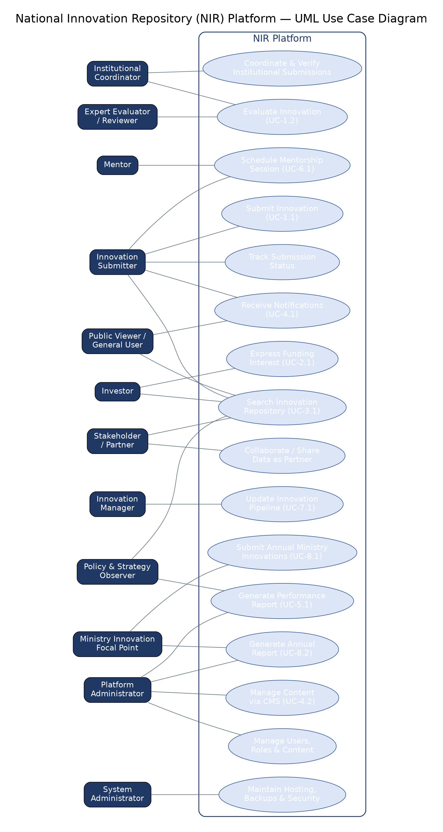
Figure 1: NIR Platform — Consolidated UML Use Case Diagram

3.9.2 UML Activity Diagrams per User Category
Each diagram below corresponds to the primary use case(s) already defined for that user category in Section 3 (referenced in parentheses).
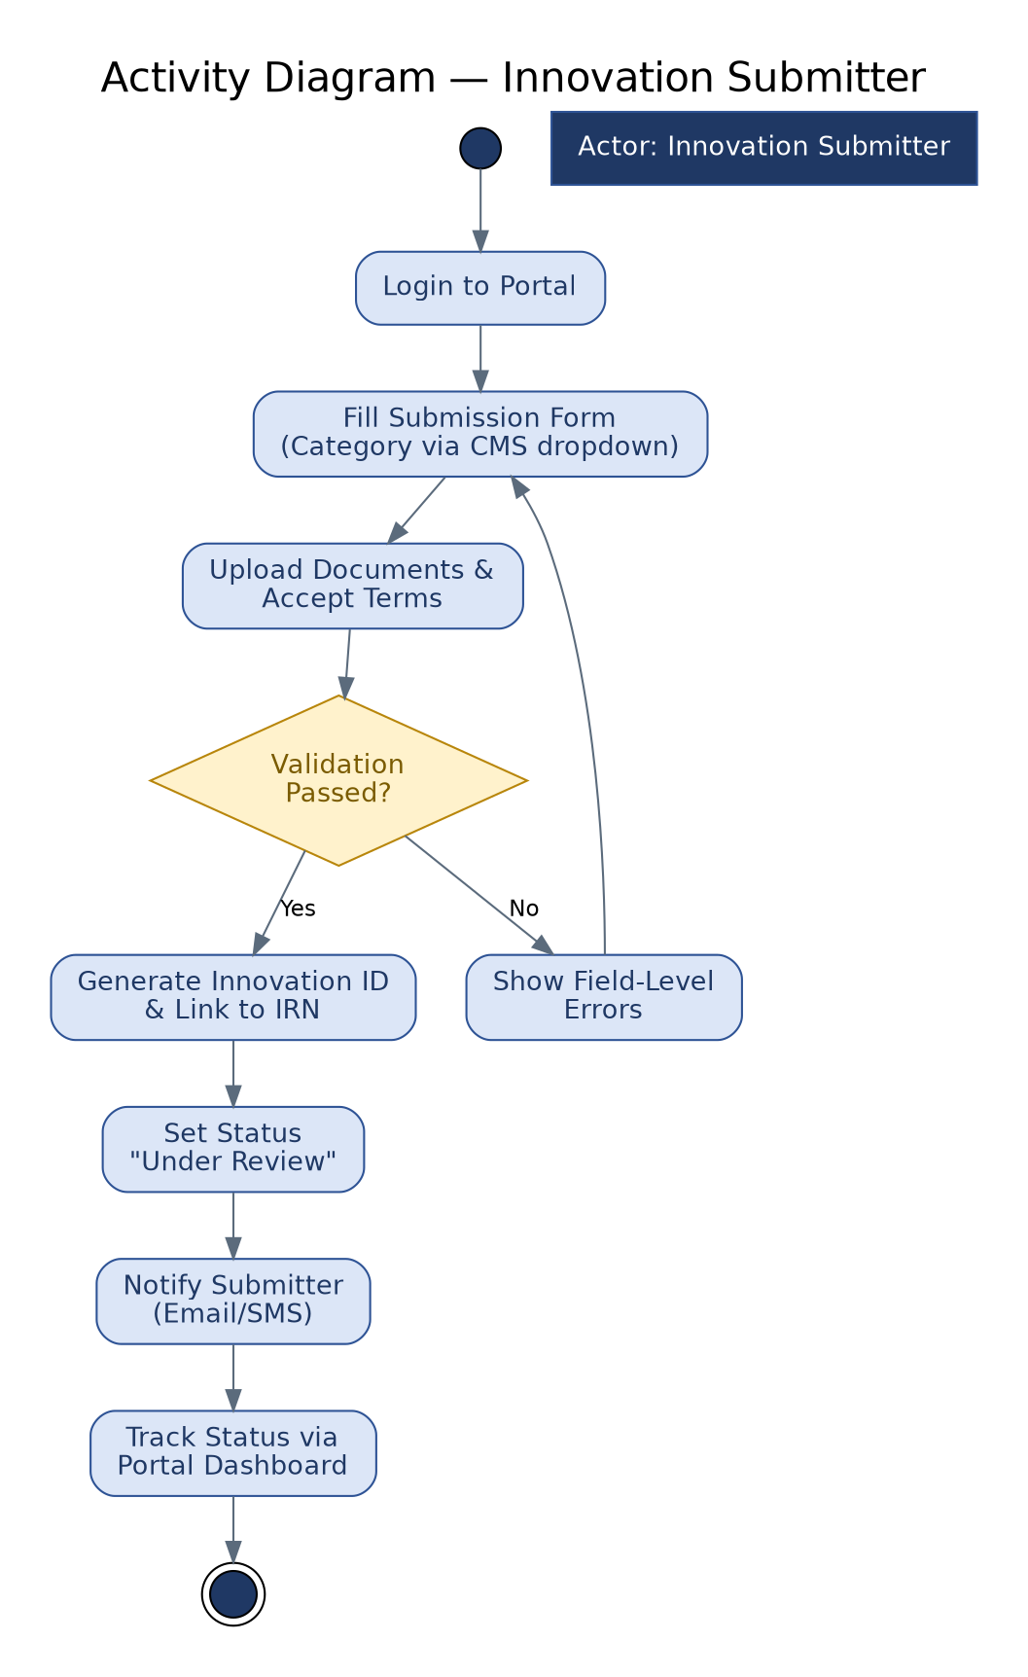
Figure 2: Activity Diagram — Innovation Submitter (ref. UC-1.1, FR-C1.M1)
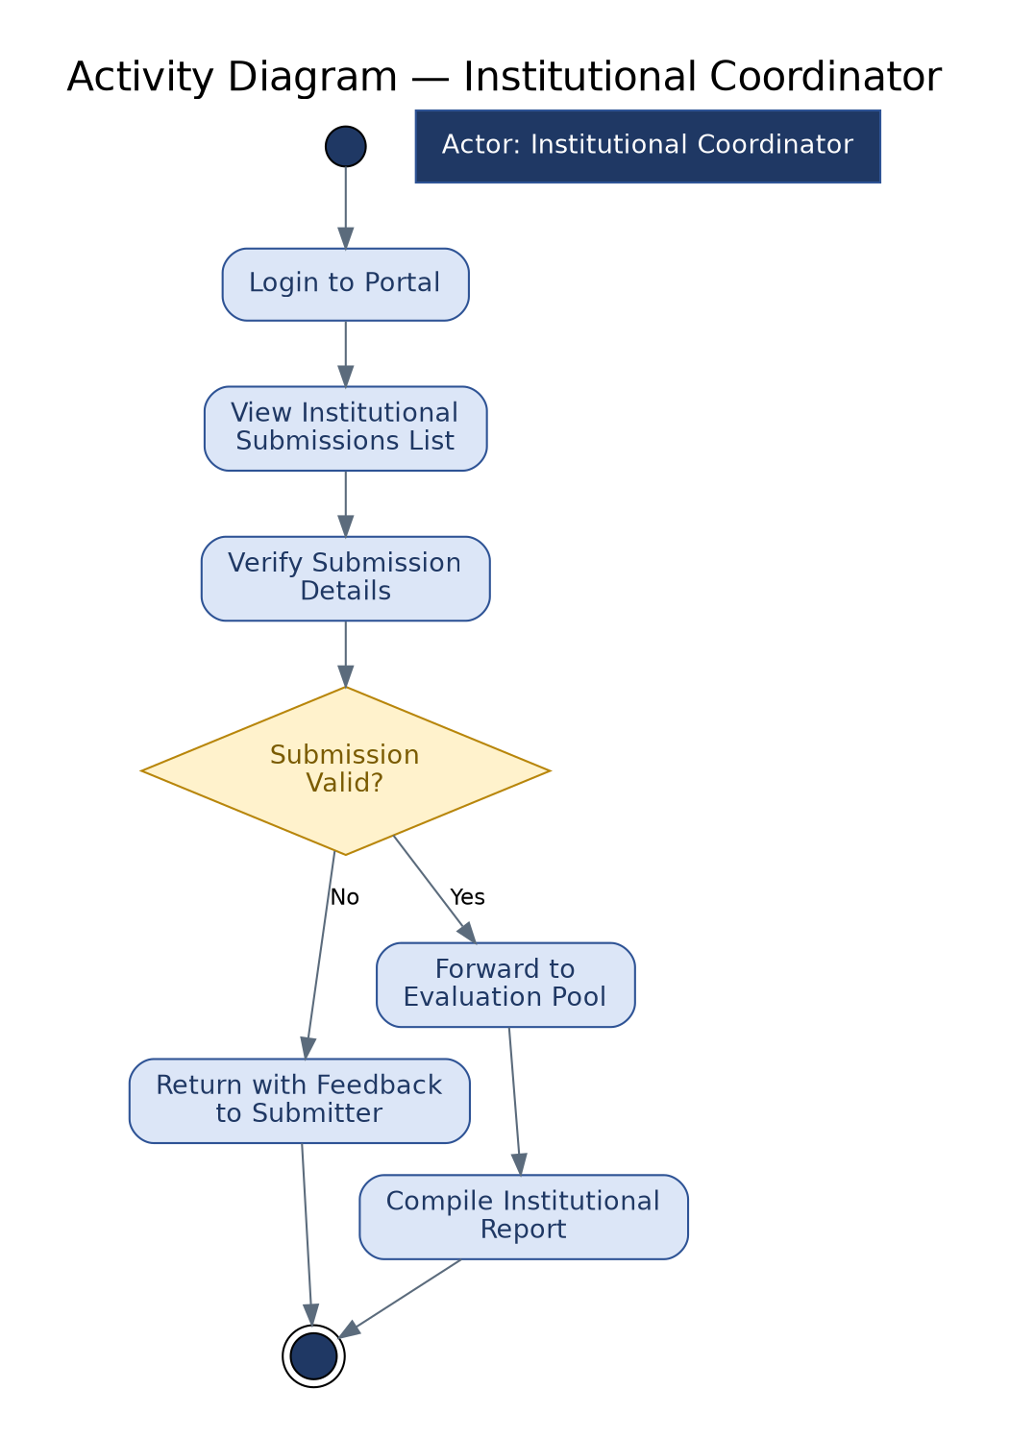
Figure 3: Activity Diagram — Institutional Coordinator (ref. FR-C1.M2, Section 2.3)

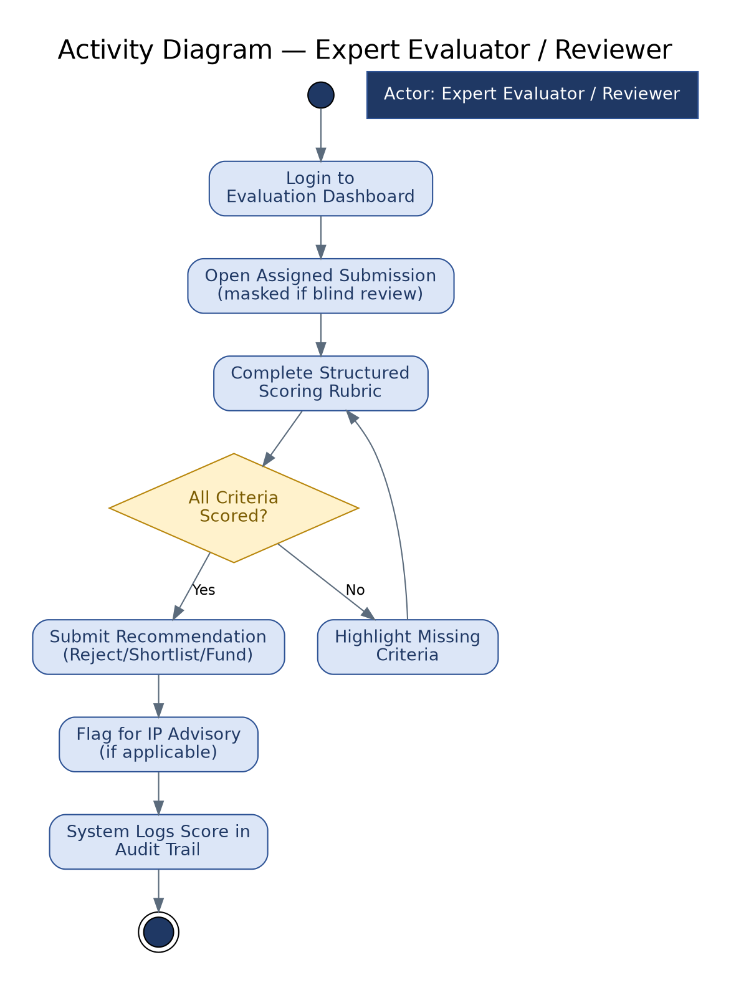
Figure 4: Activity Diagram — Expert Evaluator / Reviewer (ref. UC-1.2, FR-C1.M2)
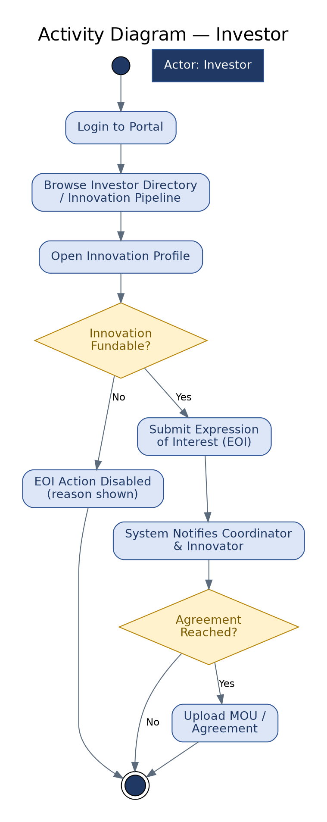
Figure 5: Activity Diagram — Investor (ref. UC-2.1, FR-C2.M1)

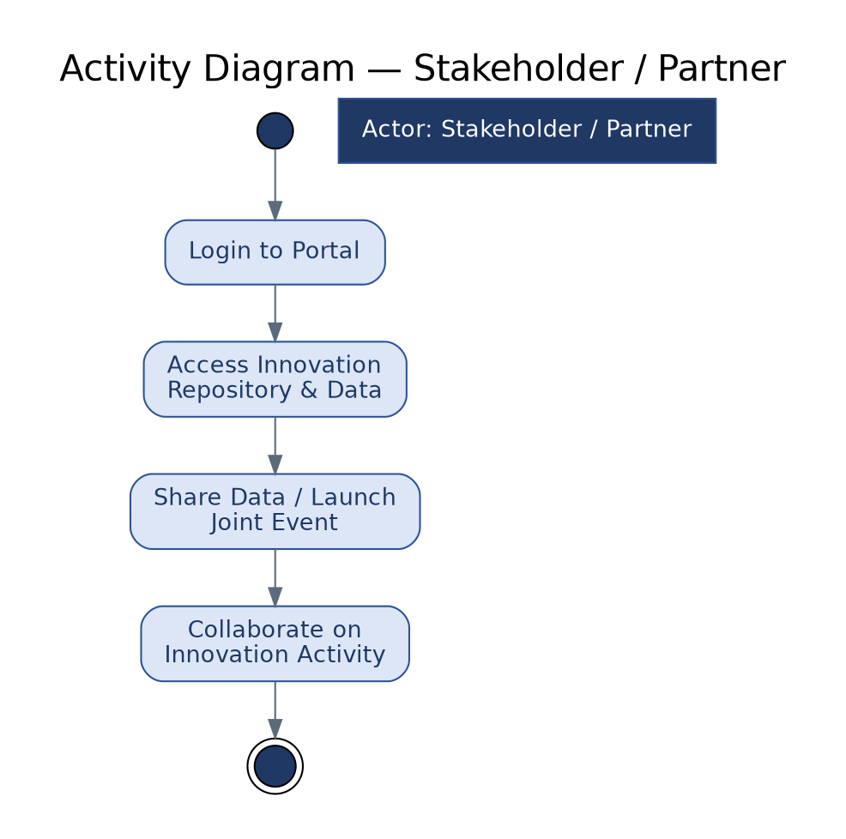
Figure 6: Activity Diagram — Stakeholder / Partner (ref. Section 2.3)
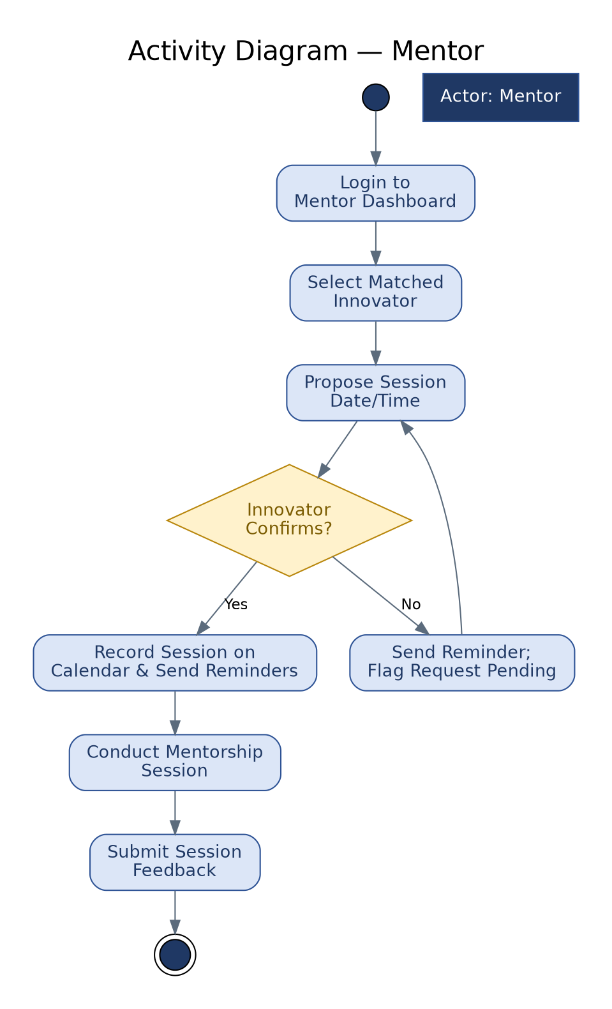
Figure 7: Activity Diagram — Mentor (ref. UC-6.1, FR-C6.M1)

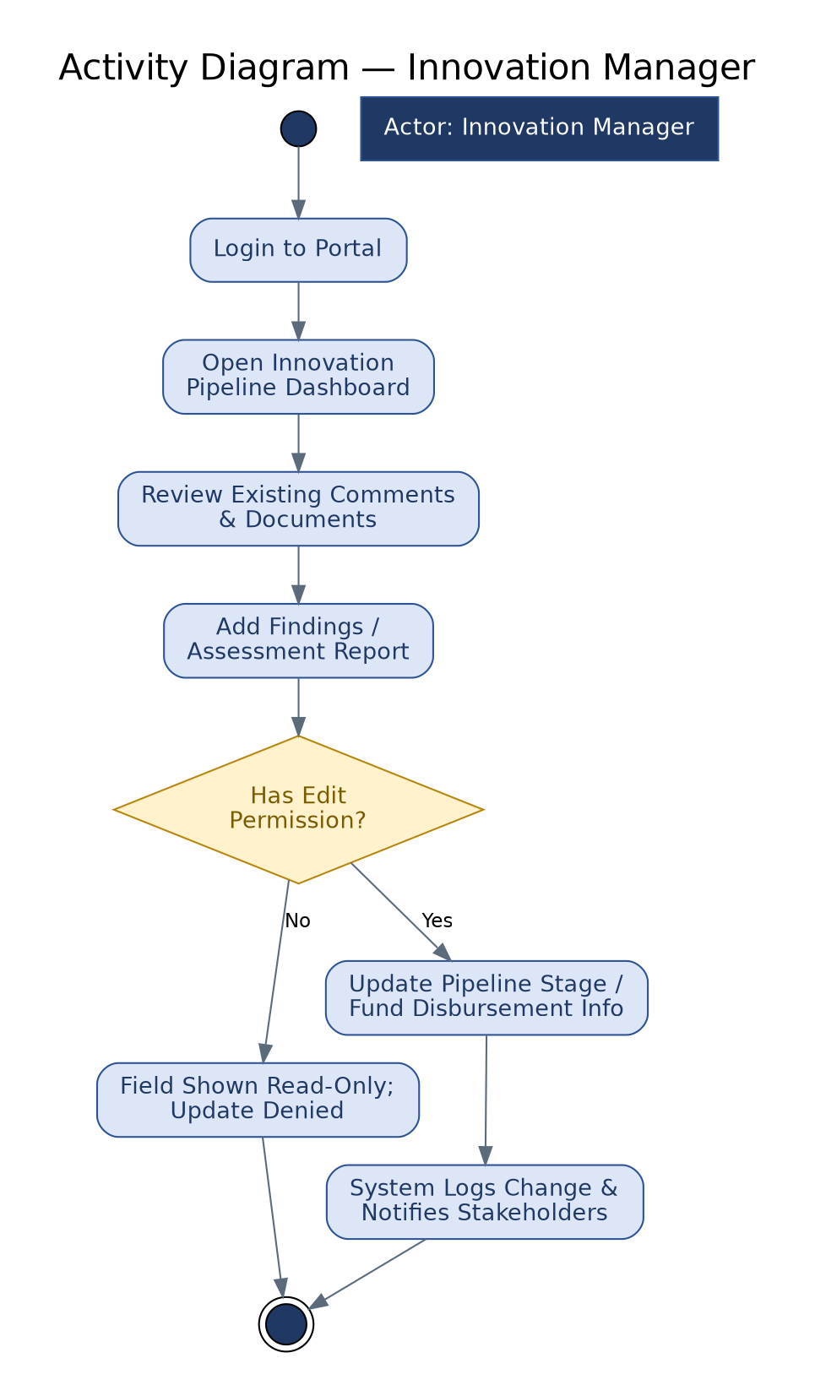
Figure 8: Activity Diagram — Innovation Manager (ref. UC-7.1, FR-C7.M1)
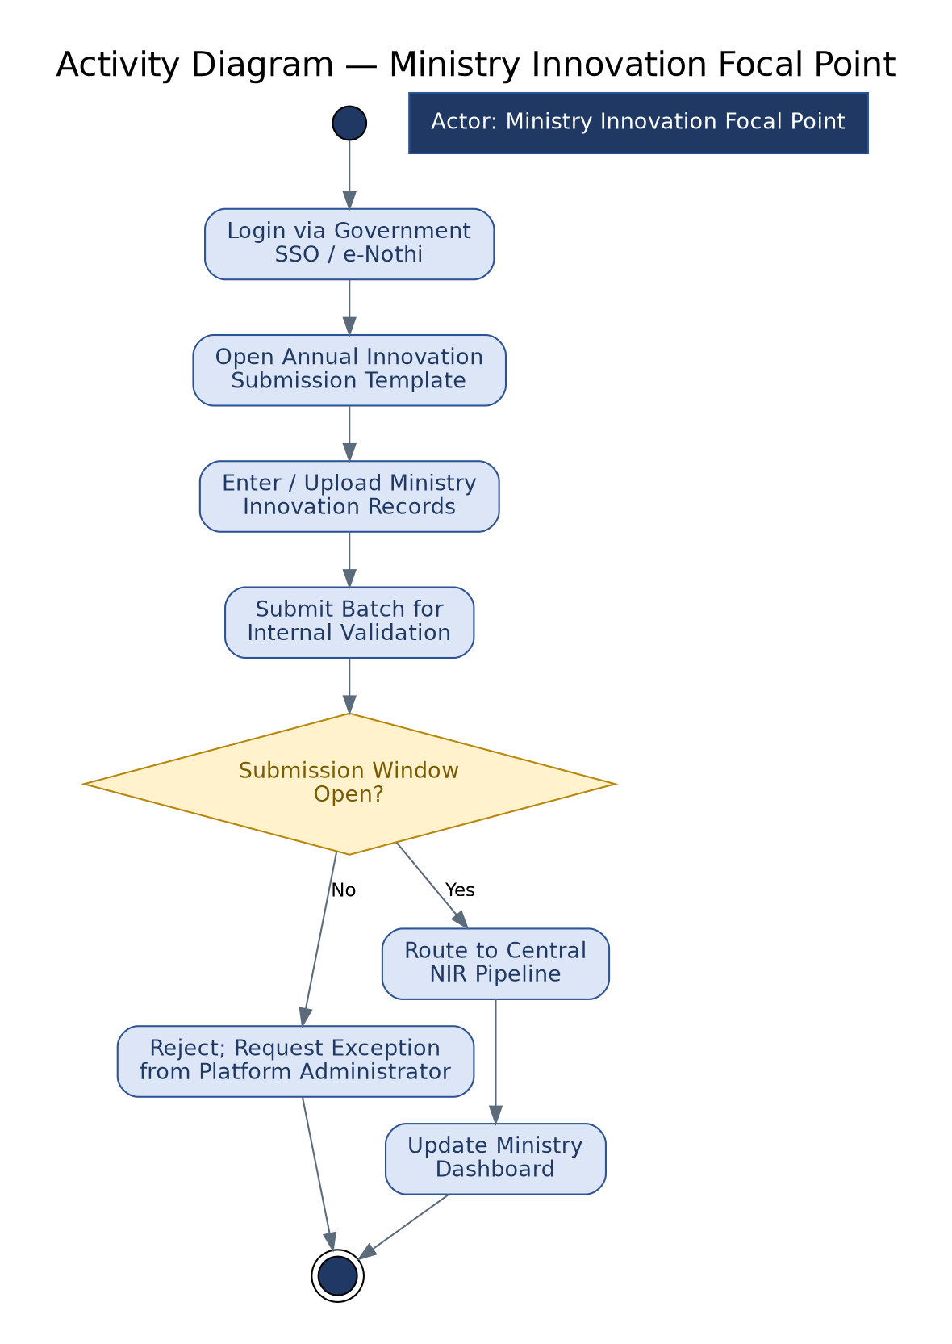
Figure 9: Activity Diagram — Ministry Innovation Focal Point (ref. UC-8.1, FR-C8.M1)

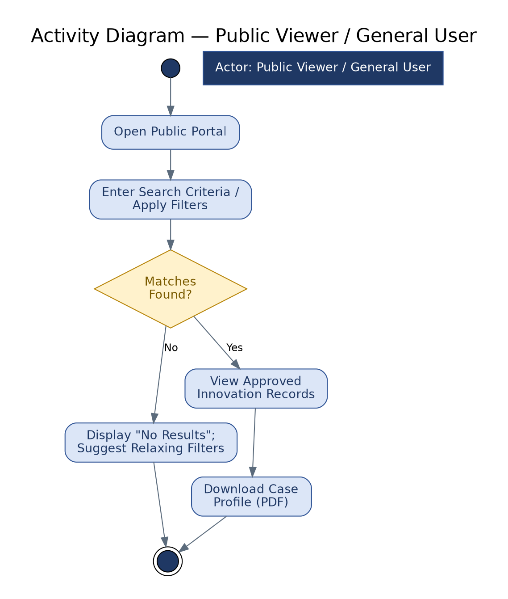
Figure 10: Activity Diagram — Public Viewer / General User (ref. UC-3.1, FR-C3.M1)
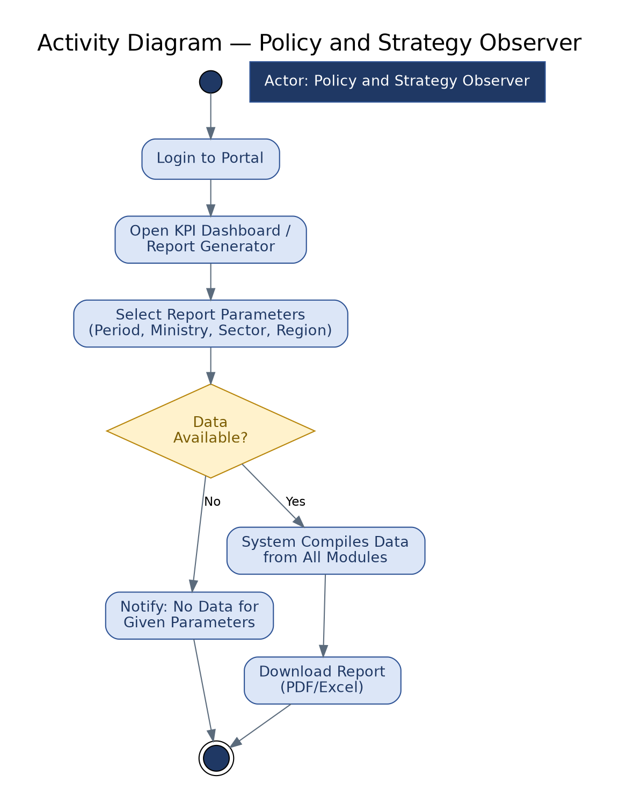
Figure 11: Activity Diagram — Policy and Strategy Observer (ref. UC-5.1, FR-C5.M1)

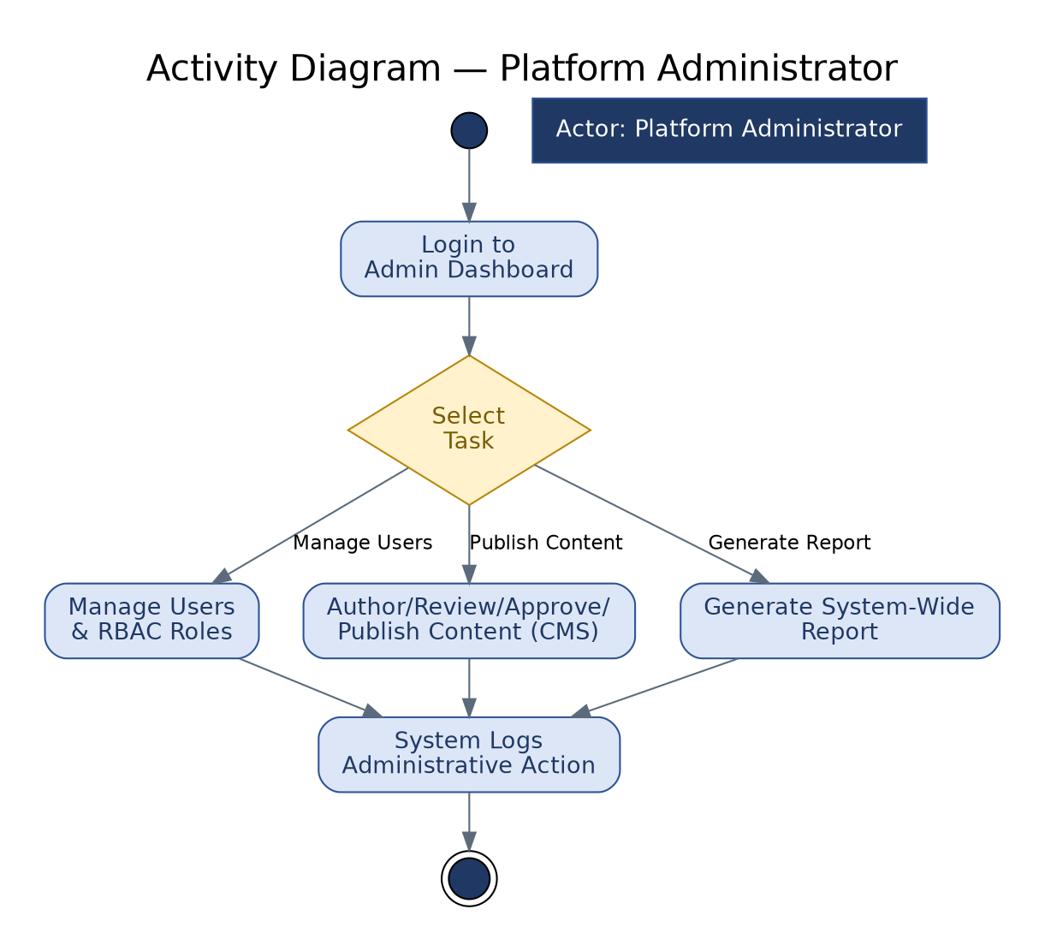
Figure 12: Activity Diagram — Platform Administrator (ref. UC-4.2, FR-C4.M2, Section 5.2.3)
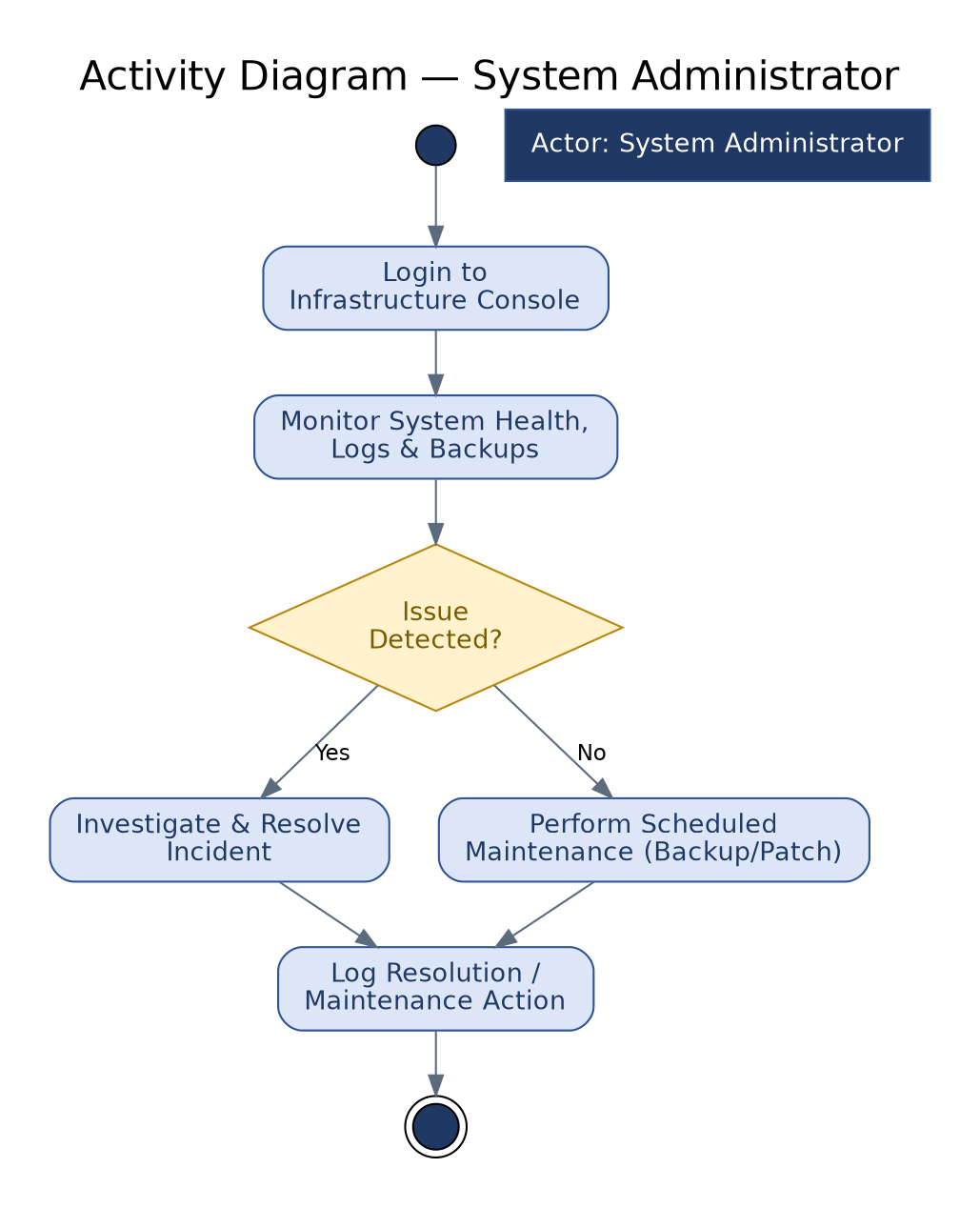
Figure 13: Activity Diagram — System Administrator (ref. Section 5.3, 5.2.4)

4. External Interface Requirements

4.1 User Interfaces
- The system shall provide a responsive web interface for desktop, tablet, and mobile browsers (Chrome, Firefox, Safari, Edge).
- The interface shall be available in Bangla and English with a persistent language-toggle control.
- The interface shall conform to WCAG 2.2 Level AA and the Government of Bangladesh's Digital Service and Web Designing Guideline for Inclusive Accessibility (2022).
- Distinct, role-appropriate dashboard views shall be provided for innovators, evaluators, mentors, investors, ministries, and administrators.

4.2 Hardware Interfaces
The system has no direct hardware interface requirements beyond standard server, storage, and network hardware provisioned at the National Data Center (NDC), as detailed in Section 5.3 (Reliability & Availability) and the TOR's Hosting Requirements.

4.3 Software Interfaces
In addition to the external systems below, all NIR modules interface internally with the platform's central Content Management System (CMS — Section 3.4.2), which serves as the single source of truth for portal content, blog/FAQ content, and notification templates.
External System | Purpose | Interface Type | Responsible Agency
Content Management System (CMS) | Centralized authoring/publishing of portal content, blogs, FAQs, and notification templates consumed by all modules | Internal REST API (headless) | a2i-managed / Vendor-operated
NID / Birth Registration (BRC) | Identity verification of registered innovators | Secure API | Election Commission, Local Government Division (LGD)
SMS Gateway | OTP delivery, alerts, milestone notifications | API | Telecom Operators
BIN Verification API | Investor identity/registration verification | API | National Board of Revenue
e-Nothi | Administrative approvals, memos, and action logging | Bidirectional API | Cabinet Division
Google Maps | Location tagging of innovation submissions | API | Third-party (Google)
SSO Providers (Google, Apple) | Third-party authentication | OAuth 2.0 / OIDC | Third-party
SMTP / Email Gateway | Transactional email notifications | SMTP/API | a2i-managed
University & Government Systems (30+) | Data integration via API or file exchange | API / File Exchange | Respective institutions/agencies

4.4 Communication Interfaces
- The system shall expose RESTful APIs, secured via API keys/OAuth 2.0, for all integrations with external systems.
- A dedicated API Gateway shall manage traffic, enforce rate limiting/throttling, and log all external API interactions.
- APIs shall support JSON as the primary payload format, with XML supported where required by counterpart systems.
- Comprehensive API documentation (e.g., Swagger/OpenAPI) shall be delivered covering both public and restricted endpoints.

5. Non-Functional Requirements
The non-functional requirements (NFRs) below define the operational qualities the platform must exhibit. Each is assigned an identifier of the form NFR-<category>.<sequence> for traceability.

5.1 Performance and Scalability
ID | Requirement | Target / Metric
NFR-PERF.01 | Concurrent user capacity | The system shall support at least 1,000 concurrent users without degradation.
NFR-PERF.02 | Search response time | Search and filtering operations shall return results in under 2 seconds.
NFR-PERF.03 | Mass submission handling | The system shall process bulk/mass submissions during innovation calls without crashing or data loss.
NFR-PERF.04 | Scalability architecture | The architecture shall allow both horizontal and vertical scaling.
NFR-PERF.05 | Auto-scaling | The platform shall support auto-scaling during peak-load periods.

5.2 Security Requirements

5.2.1 Key Security & Privacy Controls
- Intellectual property and innovation submissions shall be protected from unauthorized access, misuse, or leakage.
- Personal data (NID/Birth Registration details, contact information, affiliation) shall be encrypted at rest and in transit using industry-standard protocols; sensitive data shall never be stored or transmitted in plain text.
- Role-Based Access Control (RBAC) with multi-level permissions shall restrict access to data and functions by user class.
- All administrative changes, approvals, data access, and downloads shall be captured in an audit trail.
- Data in transit shall be protected via SSL/TLS; data at rest shall be protected via database encryption.
- Inactive sessions shall be subject to automatic timeout and logout.
- Multi-factor authentication (MFA) shall be enforced for high-privilege roles (administrators, evaluators, funders).
- File uploads shall be virus-scanned and restricted by file type; document handling shall be tamper-evident.
- The system shall support data anonymization/masking for blind-review evaluation workflows (see FR-C1.M2.06).

5.2.2 Minimum Security Controls
The vendor shall implement and test protection against, at minimum:
- Cross-Site Scripting (XSS)
- Cross-Site Request Forgery (CSRF)
- SQL Injection
- Session hijacking and fixation
- Unvalidated input/output
- Insecure file access and uploads
- Broken authentication or access control
- Business-logic abuse (e.g., workflow bypass)
Development shall be guided by the OWASP Top 10 and the Comprehensive Lightweight Application Security Process (CLASP).

5.2.3 Access, Audit & Accountability
- All user activity (login, logout, submission, edits, approvals) shall be logged.
- Audit logs shall be tamper-proof and accessible only to authorized administrators/auditors.
- The system shall support need-to-know access delegation and privilege revocation.
- Logs shall specifically record: changes to innovation records; approvals and scoring; downloads/access of restricted files; and failed login or unauthorized access attempts.
- Audit logs shall be exportable for audit purposes and retained for a minimum of two (2) years.

5.2.4 Hosting Security & Governance
- The platform shall be hosted at the National Data Center (NDC) under BCC, or another a2i-approved environment, with firewalls, intrusion detection, and load balancing.
- Daily backups and disaster-recovery mechanisms shall be in place.
- API communication with third-party systems (NID/BRC, BIN, e-Nothi, and other government APIs) shall be secured via API keys and encryption protocols.

5.2.5 Security Testing & Compliance
- Regular vulnerability assessments and penetration testing shall be conducted, with test reports submitted to the project team.
- A security checklist shall be maintained and updated after every release cycle.
- A dedicated security team shall monitor risks and respond to breaches or anomalies.
- A security test report shall be submitted after completion of each module, prior to progressing to the next development phase.

5.3 Reliability and Availability (Business Continuity)
- The system shall maintain a High-Availability (HA) configuration with 99.9% uptime.
- Disaster recovery backups shall occur at least every 24 hours.
- Redundant storage shall be provided for critical data and documents.
- Failover mechanisms shall activate automatically in the event of hardware or network failure.

5.4 Usability and Accessibility
- The interface shall be clean and intuitive, tailored to each user class (innovator, reviewer, mentor, admin, etc.).
- A persistent language toggle (Bangla/English) shall be available across the portal.
- UX design shall conform to Government of Bangladesh branding and design standards.
- The platform shall comply with WCAG 2.2 Level AA, including alt-text, screen-reader compatibility, keyboard navigation, and appropriate color contrast/font sizing.

5.5 Maintainability and Portability
- Source code shall follow OWASP secure coding guidelines, be well-commented, and use a version control system (e.g., Git) with access shared with the project authority.
- The system shall use reusable, modular components and services to support long-term maintenance.
- CI/CD tooling (e.g., GitHub Actions, GitLab CI, Jenkins) and containerization (e.g., Docker) are strongly encouraged to support portability and automated deployment.
- All portal content, blog/FAQ entries, and notification templates shall be maintainable by non-technical administrators through the CMS (Section 3.4.2) without requiring a code change or redeployment.

5.6 Interoperability and Data Exchange
- Standardized APIs shall support integration with NID/Birth Registration, BIN, SMS Gateway, e-Nothi, and other systems listed in Section 4.3.
- The system shall support JSON and XML formats for structured data exchange.
- The architecture shall be service-oriented and modular to allow future integrations (e.g., AI-based evaluation, startup directories, patent registries) with minimal disruption.

5.7 Localization and Language Support
- All interfaces, notifications, and communications shall support both Bangla and English.
- All input fields shall accept Unicode Bangla content.

5.8 Documentation, Coding Standards, and Quality Assurance
- The vendor shall deliver system architecture documentation, API documentation, admin/user manuals, a deployment/troubleshooting guide, and a security checklist/compliance summary.
- Functional, security, and performance testing shall be conducted, with a minimum of 80% unit test coverage.
- A structured User Acceptance Test (UAT) shall be conducted with real stakeholders, culminating in a signed UAT report.
- The vendor shall submit a Quality Assurance (QA) plan including a requirements traceability matrix (see Section 7).

5.9 Compliance and Legal Requirements
- All source code, documents, and outputs developed under this project shall be the property of the Government of Bangladesh.
- The vendor shall sign an intellectual-property and confidentiality agreement.
- Code handovers shall occur periodically (every one (1) month from the first delivery milestone), each including source code, deployment scripts/config, versioned changelog, UML diagrams, API documentation, and frontend/mobile documentation as applicable.
- Final project closure shall be approved only after full source code and documentation have been submitted, tested, and validated by a2i.

6. Data Requirements and Legacy Data Migration

6.1 Core Data Entities
The following core entities are anticipated in the NIR data model; the vendor shall finalize the entity-relationship design during the System Design phase (see the parent TOR, Section 11.3):
Entity | Key Attributes (indicative) | Related Identifier
Innovator | Name, NID/BRC reference, affiliation, contact details, role | Innovator Recognition Number (IRN)
Innovation | Title, category, description, location, attachments, status, SDG/thematic tags | Innovation ID
Evaluation | Evaluator ID, rubric scores, comments, recommendation | Linked to Innovation ID
Investor | BIN reference, organization, sector interest | Investor ID
Mentor | NID reference, expertise area, availability | Mentor ID
Ministry Submission | Ministry code, reporting year, submitted innovations | Ministry ID
Fund Disbursement Record | Innovation ID, amount, source, date, status | Disbursement ID
Content Item (CMS) | Type (page/blog/FAQ/template), language variants, status (draft/review/published), version history, author | Content ID

6.2 Legacy Data Migration
Where legacy innovation data exists within government or institutional archives, the vendor shall propose and execute a migration strategy comprising:
- Data extraction from identified legacy sources.
- Transformation and cleansing to conform to the NIR data model.
- Validation of migrated records against source data.
- Upload into the NIR repository with correct attribution and Innovation ID assignment.
The vendor shall provide a template for estimating legacy data volume prior to migration.

7. Requirements Traceability Matrix (Summary)
The table below maps each functional area to its source in the TOR and its corresponding SRS section, to support verification that all TOR-mandated scope has been captured. A full requirement-by-requirement traceability matrix (mapping every FR-ID to design elements and test cases) shall be maintained by the vendor as a living document throughout the project, per Section 5.8.
Component | Name | TOR Reference | SRS Reference
C1 | Innovation Submission & Evaluation System | TOR §5.1 | SRS §3.1
C2 | Innovation Funding Matchmaking | TOR §5.2 | SRS §3.2
C3 | Repository & Knowledge Management | TOR §5.3 | SRS §3.3
C4 | Communication & Stakeholder Engagement | TOR §5.4 | SRS §3.4
C5 | Performance Monitoring & Reporting | TOR §5.5 | SRS §3.5
C6 | Mentorship & Expert Guidance | TOR §5.6 | SRS §3.6
C7 | Innovation Management | TOR §5.7 | SRS §3.7
C8 | Ministry Innovation Submission & Annual Reporting | TOR §5.8 | SRS §3.8

Cross-Cutting Area | TOR Reference | SRS Reference
Users and User Roles | TOR §6 | SRS §2.3
Security and Privacy Requirements | TOR §7 | SRS §5.2
Integration Requirements | TOR §8 | SRS §4
Hosting Requirements | TOR §9 | SRS §5.3, §2.4
Non-Functional Requirements | TOR §10 | SRS §5
Scope of Work / Deliverables | TOR §11 | SRS §2.6, §5.8, §8

8. Appendices

Appendix A: Deployment and Delivery Phases (Reference)
Phase | Key Deliverables
Inception | Inception Report, Project Plan
Analysis | Approved SRS (this document)
Design | UI/UX assets, architecture documentation, API design, System Design Document (SDD)
Development | Source code, integration APIs
Testing | Test plans, test reports, UAT report
Deployment | Deployment guide, hosting setup report
Training | Training materials, recorded video tutorials
Knowledge Transfer | Full codebase, admin manual, technical walkthrough
Support | SLA document, maintenance logs, issue tracker
Data Migration | Cleaned and migrated legacy innovation dataset

Appendix B: Use Case Index
Full use case narratives appear in Section 3 alongside their respective module. This index is provided for quick reference.
Use Case ID | Title | Module
UC-1.1 | Submit a New Innovation | C1.M1 – Innovation Registration & Submission
UC-1.2 | Evaluate a Submitted Innovation | C1.M2 – Evaluation & Recognition
UC-2.1 | Express Interest in an Innovation | C2.M1 – Investor & Funding Matchmaking
UC-3.1 | Search the Innovation Repository | C3.M1 – Innovation Repository & Search
UC-4.1 | Receive a Milestone Notification | C4.M1 – User Interface & Communication
UC-5.1 | Generate an On-Demand Performance Report | C5.M1 – Performance Monitoring & Reporting
UC-6.1 | Schedule a Mentorship Session | C6.M1 – Mentor Engagement & Guidance
UC-7.1 | Update Innovation Pipeline Status | C7.M1 – Innovation Pipeline Setup
UC-8.1 | Submit Annual Ministry Innovations | C8.M1 – Ministry Innovation Submission
UC-8.2 | Generate the Annual Innovation Report | C8.M2 – Annual Reporting & Performance Tracking

Appendix C: Partner / Innovation Community Reference
The following organizations were identified in the TOR as part of the broader innovation ecosystem and may be relevant to stakeholder consultation, integration scoping, or content partnerships:
- UNDP Accelerator Lab
- UNDP Youth Co:Lab
- UNICEF Innovation Lab
- International Centre for Climate Change and Development
- Light Castle Partner
- MIST Innovation Club
- NITER Business & Innovation Club (NBIC)
- Innovation, Creativity and Entrepreneurship (ICE) Center, Dhaka University
- Institute of Information Technology, Dhaka University
- Bangladesh Institute of ICT in Development (BIID)
- Bangladesh Youth Environmental Initiative (BYEI)
- BUET Innovation and Designing Club (BIDC)
- AUST Innovation & Design Club
- University Innovation Hub Programme, UIU
- Bangladesh Innovation Conclave
- YGAP
- YY Ventures
- r-ventures
- GP Accelerator
- BRAC Social Innovation Lab
- Sajida Foundation
- Impact Hub
- NSU Startups Next
- Orange Corner Bangladesh
- GEN Bangladesh
- NEXT Ventures
- Anchorless Bangladesh
- SBK Tech Ventures
- Bangladesh Youth Leadership Center (BYLC)

Appendix D: Open Items for Vendor Confirmation During Design
The following items were marked as indicative or to-be-determined in the source TOR and require confirmation/finalization by the vendor during the System Design phase:
- Calendar integration technology for mentorship session scheduling (FR-C6.M1.03).
- Final RBAC permission matrix for all 12 user classes (Section 2.3).
- Detailed volume estimate and migration plan for legacy innovation data (Section 6.2).
- Final technology stack selection, subject to a2i's preference for open-source tools (Section 2.5).
- Selection of the specific CMS platform (e.g., an open-source headless CMS such as Strapi or Directus, or a traditional CMS operated in headless mode) to implement Component 4, Module 2 (Section 3.4.2), subject to a2i's preference for open-source tools.

